SHERIN SANS 2437051 1MAECO

Code 1: SELECT* FROM crime_scene_report LIMIT 5;

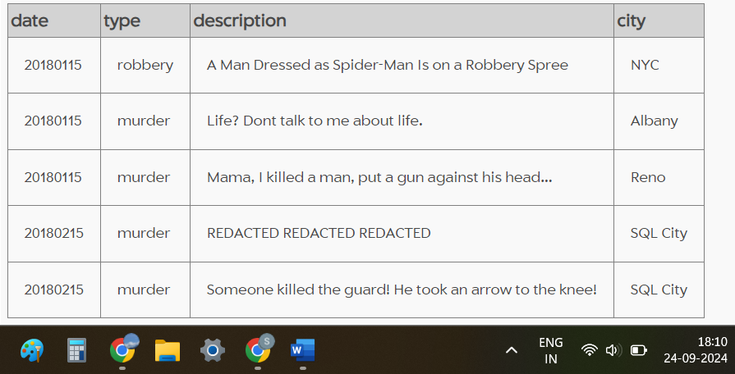

Code 2: SELECT * FROM crime_scene_report WHERE type="murder";

Code 3: SELECT * FROM crime_scene_report WHERE type = "murder" AND date = "20180115" AND city = "SQL City";

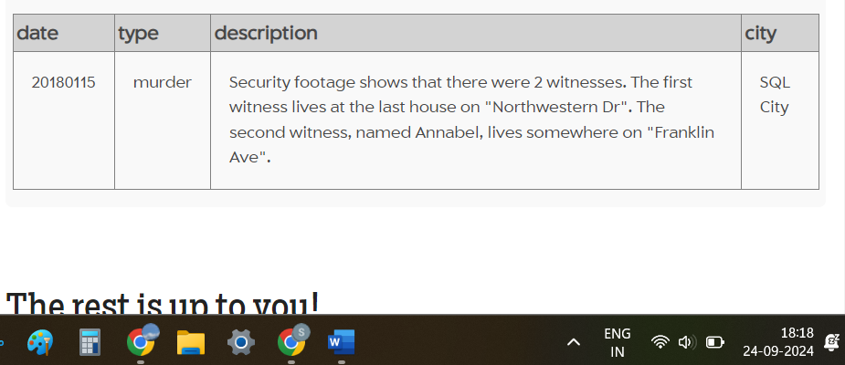

Code 4: SELECT * FROM person LIMIT 5;

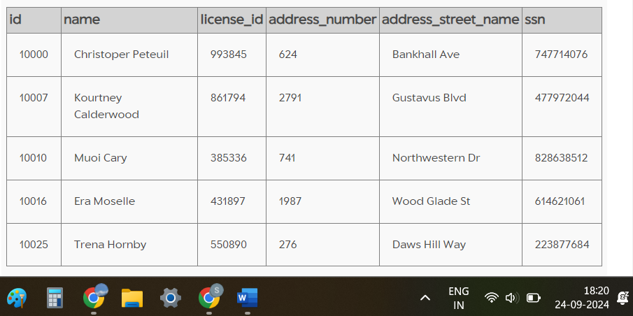

Code 5: SELECT * FROM person WHERE address_street_name = "Northwestern Dr" ORDER BY address_number DESC;

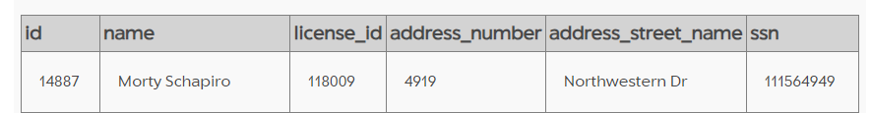

Code 6: SELECT * FROM person WHERE name LIKE '%Annabel%' AND address_street_name = "Franklin Ave";

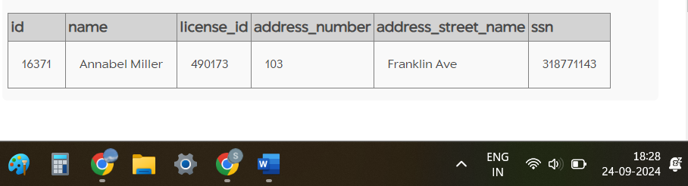

Code 7: SELECT * FROM interview WHERE person_id IN ("14887", "16371");

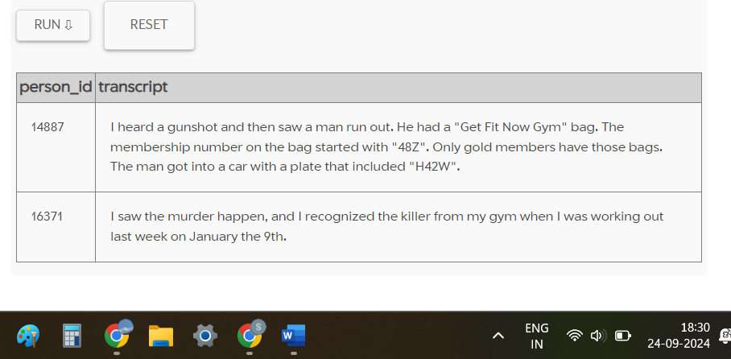

Code 8: SELECT * FROM get_fit_now_check_in WHERE membership_id LIKE '48Z%' AND check_in_date = "20180109";

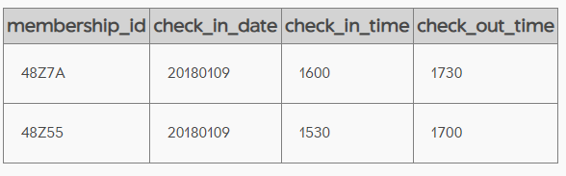

Code 9: SELECT * FROM drivers_license WHERE gender = "male" AND plate_number LIKE '%H42W%';

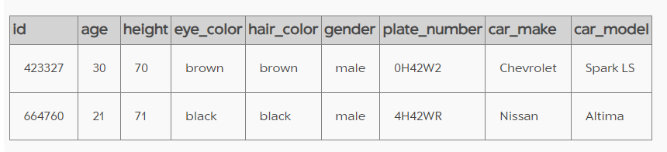

Code 10: SELECT * FROM person WHERE license_id IN ("423327","664760");

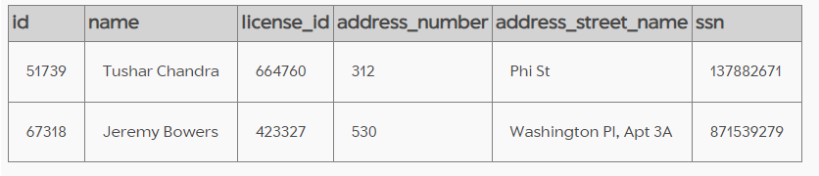

Code 11: SELECT * FROM get_fit_now_member WHERE person_id IN ("51739", "67318")

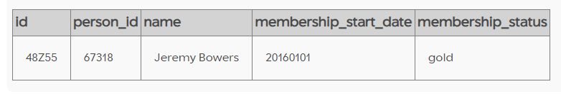

Code 12: INSERT INTO solution VALUES (1, 'Jeremy Bowers');

SELECT value FROM solution;

